Dark yet welcoming, the restaurant pulled them in with its ambiance.
The plastered walls were sponged in color blocks of a deep red and black. The ceilings were painted in a high polish black and stone black tile lined the floor. Striking kabuki masks and detailed silk kimono robes lined the walls

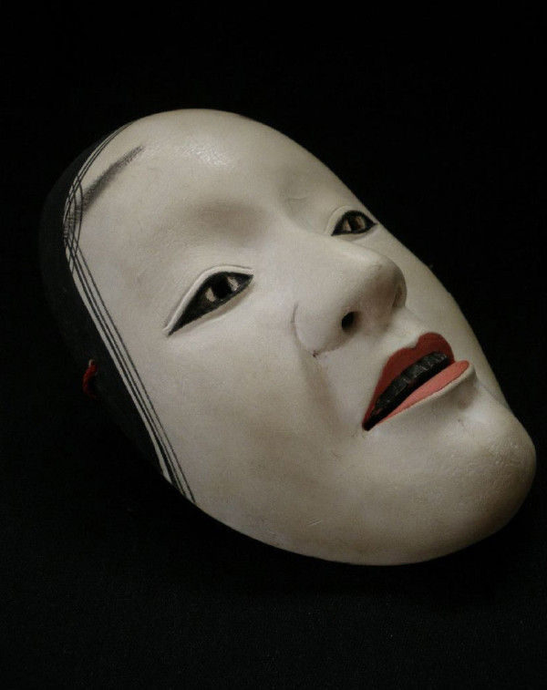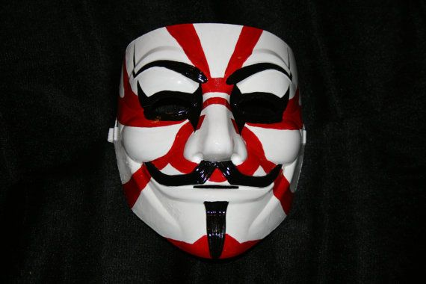

The women shared the restaurant with no one except the spiciness of sriracha seasonings and robust scent of the rich soy sauce that filled the air. They sat on their high top stools at the bar, enjoying the food and the reprieve from the heat.
“Air conditioning is nice, huh?” Noel asked.
“Yes, I’ll give you that. I forgot how sticky this weather can be. I think we have to get used to having bad hair and make up days.”
“I think you’re right.”
Suzanne finished sipping the last of the broth. “The soup is amazing. It’s not the kind of cuisine I had in mind for our vacation in Key West, though.”
“I had no clue this was even here. But, I needed this…helped with my hangover.”
“Feel better?”
“Absolutely. I think I can tackle a Sandhill Hooker shot or two today. After all, we are on the infamous Duval Street.”
“Okay, pickle juice that way…now you’re talking.”
She looked around the place and smiled. “It’s pretty cool in here.”

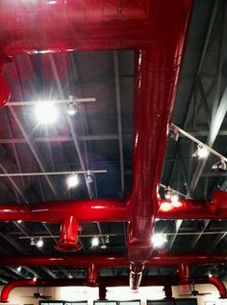

Suzanne leaned her head back. “And look at how high the ceiling is. I like all that exposed ductwork. I wonder what this place was before?”
“This used to be a club,” said the waitress as she carried in a case of liquor from the kitchen to the bar.
“This was a club?” Suzanne asked.
“Yeah. You two new to Key West?”
“First time here.”
Noel sat quietly listening to the conversation unfold between Suzanne and the waitress.
“You want a little history on this building you won’t hear about on any tour guide?” The waitress asked as she unpacked the box and carefully placed the bottles on the lighted shelves behind the bar.
“Sure.”
“This restaurant and the entire vacant spot next door used to be one big club.” The waitress turned around and pointed towards the ceiling. “There was an entire second floor up there. The owners of the restaurant demolished it since the place is small and narrow. The height makes it feel spacious. You can sorta tell how it looked like the second floor with that small area they kept above the kitchen. The red spiral staircase you see leading up to that area…that’s original to the building.”
“Yeah, taking the second floor out does make it feel bigger. So the club must’ve been packed all the time to have two floors, huh?”
The waitress laughed and leaned against the counter. “They didn’t advertise. And you notice it’s off of Duval right?”
The women nodded.

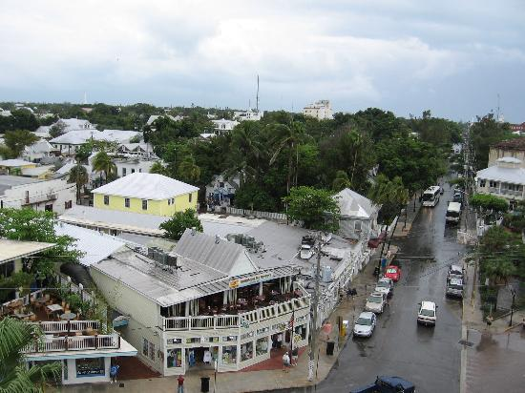

“Not much foot traffic on this street like Duval. This was the hush-hush place. You had to get invited. Secret door knock and password would let you in—extremely private and exclusive.”
“You ever get invited?”
“Oh, God, no. I have no idea who got invited, but I wasn’t one of them. In fact, I never knew the club existed until a friend told me that the owners were going to put the building up for sale a few years ago. I was like, ‘what club?’ And the thing was, I walked past the place many times and always thought it was an abandoned building.”
“So what was the deal? Why was it private? What went on?”
“Rumors claimed it as an adult playground.”

“If the place was still in operation, somehow I know Suzanne would get an invite,” Noel chimed in.
Suzanne flashed a wicked smile.
“Possibly,” the waitress said. “Get’s your thoughts going, right? Like, what exactly happened in there? Who went there? But the one thing I was always curious about was seeing the place. They say it was like being on another planet.”
Noel awaited a break in the conversation to jump back in with her questions. But movement from out of the corner of her eye caught her attention. She snapped her head to look at the loft area and gasped.
“What?” the waitress asked in a concerning tone.
She scanned the area in confusion.
“What’s wrong?” Suzanne asked.
“I-I thought I saw something up there.”
The waitress peered into the kitchen. “Can’t be. No one else is here except Jesse and he’s at sink.”
“What’s that door up there?”
“That’s the access point to the space next door, but its sealed shut from the other side. Trust me. I’ve tried to see if I could get in to sneak a peek.”
“What is it that you think you saw?” Suzanne asked.
She shrugged her shoulders as goose bumps paraded along her skin. The same feeling stirred again—as if she were being watched. “I thought I saw someone looking down on us from that railing.”
Suzanne turned to the waitress. “We partied a bit last night.”
“That tends to happen in Key West.”
“I think we’ll take the check and I’ll get this one out for some much needed fresh air and vitamin D.”
“Sure thing.”
“I’m not crazy, Suzanne,” she whispered as she reached for her purse.
“I didn’t say you were. I just think you need to get outside.”
“Sammy told you right?”

“What?”
“The boat? Me freaking out that someone was watching me last night?”

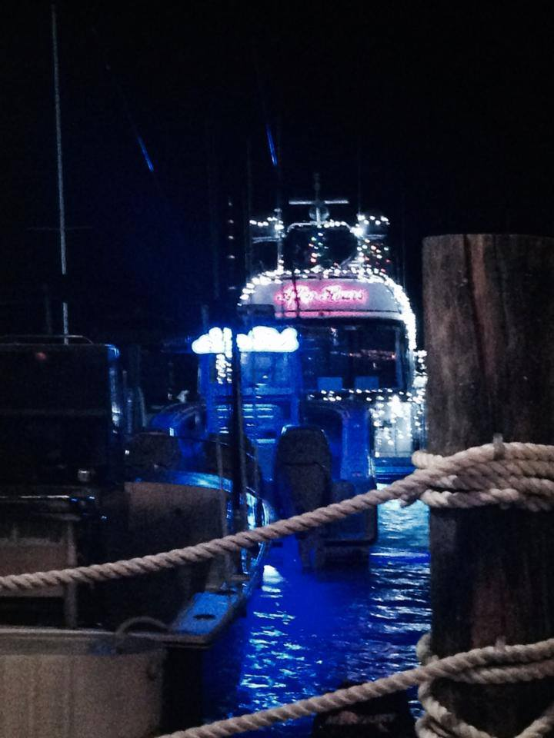

“Yes. But, honey, I think you’re just thinking of Dante being in this place and visualizing him. That’s all.”
The waitress slid the check across the counter and Suzanne immediately snatched it up. “My treat. You get drinks tonight.”
“Thanks.”
Suzanne placed the cash on top of counter. “Keep the change, darling. Thanks for the 411 on this place. Very interesting.”
“No problem. You guys go have fun.”

Amazon - http://ow.ly/ChF7d
Barnes and Noble- http://ow.ly/ChG0r
iTunes- http://ow.ly/ChFdh
Smashwords- http://ow.ly/ChFo6

Paperback coming soon!

Book Trailer: http://youtu.be/dk1_U_3klvs
Cover art: LMK Graphics
Character Photography: Visionart Photography)

Maya DeLeina is a multi-published Erotic Vampire Romance Author with Siren, Evernight and Ellora's Cave Publishing.

Her current series includes Ambrose Heights Vampires, My Naughty Vampire and Vampire Architects.

Born and raised on the Hawaiian island of Oahu, Maya could be seen at her favorite beach, Lanikai, performing with an all-girl band where she played keyboards, guitar and provided vocals, working as editor in her high school's yearbook and volunteering her time at a humane society through UH of Manoa civic groups.

In 2006, Maya relocated to Colorado. Her crystal blue oceans, waterfalls and eighty-degree year-round weather were traded for four season weather, enchanting forests and majestic mountains, which led to her rekindled love for vampires.

In winter of 2010, she penned her first manuscript and by 2011, Flesh Fantasy was under contract and released by Siren Publishing. To date, Maya’s titles includes Flesh Fantasy, Veil of Seduction, Blood of Luna, and Dark Companion, with Fire and Ice and Crimson Snow being added to her bookshelf by the end of 2014.

In mid 2014, she banded with other Colorado romance authors to form the group, Mile High Muses, in which Maya serves as "The Vamp". Catch her Forbidden Fruit Friday blog and guests she hosts on Sultry Saturdays.

Not only does Maya have theatrical book trailers that bring her sexy vampires to life, Maya and her vampires were featured in Singer/Songwriter Jill Cohn's music video "Blessing Moon".

Social Media:

Website: http://www.mayadeleina.net

Blog: http://www.milehighmuses.com

Twitter: https://twitter.com/vampauthormaya

YouTube: https://www.youtube.com/user/mayadeleina

Facebook: https://www.facebook.com/EroticVampireAuthor?ref=br_tf

Pinterest: http://www.pinterest.com/mayadeleina/

About me: http://about.me/maya.deleina

Amazon: http://ow.ly/BQw0l

Barnes and Noble: http://ow.ly/BQwac

iTunes: http://ow.ly/BQwjv

